
CHURCHLANDS SENIOR HIGH SCHOOL
MATHEMATICS SPECIALIST 3, 4 TEST ONE 2016
NON-Calculator Section
Chapters 1, 2,

Name________________________________ Time: 50 minutes
Total: 46 marks

1. [3, 2, 6 marks]

(a) If $z_{1}=2cis\left(\frac{π}{12}\right)$and $z_{2}=5cis\left(\frac{π}{6}\right)$, prove that: $z_{1}z_{2}=5\sqrt{2}(1+i)$

(b) Simplify $\frac{3cis\left(-\frac{π}{2}\right)×4cis\left(\frac{2π}{3}\right)}{2cis\left(\frac{5π}{4}\right)×cis\left(-\frac{7π}{12}\right)}$ $\frac{3cis\left(-\frac{π}{2}\right) . 4cis(\frac{2π}{3})}{2cis\left(\frac{5π}{4}\right) . cis(-\frac{7π}{12})}$

(c) Determine $z$ if: $z\overline{z}+2z=\frac{1+4i}{4}$

2. [3, 1, 1, 2, 3 marks]

(a) Represent the following set on the Argand diagram below.
{Z : }
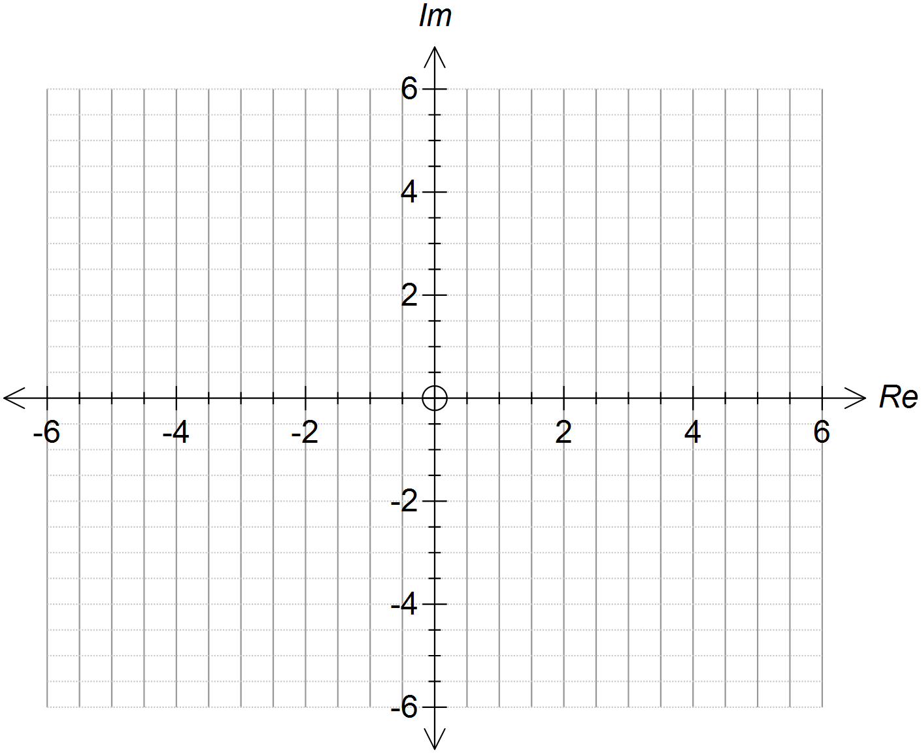

(b) Find
- the minimum possible value of Im(z)

- the maximum possible value of $\left|Re(z)\right|$

- the minimum value of $\left|z\right|$

- the maximum possible value of arg(z), leave your answer in trig form.

3 [2, 1, 3 marks]
(a) Find the remainder when ${2x}^{3}-x^{2}+2$ is divided by $x-3$

(b) If $(x-2)$ is a factor of $ax^{2}-12x+4$ find $a$.

(c) The function $f\left(x\right)=x^{4}-7x^{3}+px^{2}+qx-30$ has $(x-3)$ as a factor but a remainder of -48 is left when $f(x)$ is divided by $(x+1)$. Find $p$ and $q$.

4 [6 marks]

Find two complex numbers, w and z, in Cartesian form, such that

$iz+2w=3$ and $z-\left(1+i\right)=-2$ where $i=\sqrt{-1}$.

5 [5 Marks]
Use de Moivre’s Theorem to prove that $cos4θ=8\cos^{4}θ-8\cos^{2}θ+1$

6 [2+4+2= 8 marks]
Draw separate sketches of the following sets of points in the complex plane.

(a)

(b)

(c)

